ASTRAKHAN STATE UNIVERSITY

invites you to participate in the project

“INTERNATIONAL ACTIVITIES ONLINE AGAINST COVID-19”

|  |  |
| --- | --- |
|  | *“I never teach my pupils, I only attempt to provide the conditions in which they can learn.”*  ― *Albert Einstein* |

**The following online lectures are planned in the nearest future:**

1. **Microprocessors and Microcontrollers. Introduction**



**Speaker:** Alexey Rybakov, Candidate of Physics and Mathematics, Associate Professor, Director of the Physics and Mathematics Institute of Astrakhan State University.

In this lecture you will get acquainted with general principles of building microprocessors and microcontrollers, find out the difference between them, study their classification and architecture.

You will also have the opportunity to trace the evolution of the characteristics of microprocessors, virtually look inside, study their internal structure, and discuss modern applications.

**Duration** approximately 40 minutes.

**Preliminary date**: May 12, 15:00 Moscow time

1. **Artificial Intelligence and Machine Learning in simple words**

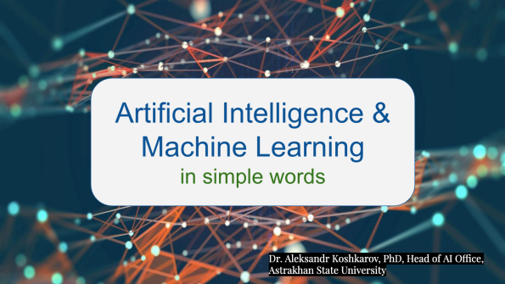

**Speaker:** Alexander V. Koshkarov, MSc Data Science (University of Sheffield, UK), Ph.D., associate professor, head of the Artificial Intelligence project office at Astrakhan State University.

The lecture is dedicated to artificial intelligence, its popular areas and practical applications.

You will learn how algorithms are trained, what is machine learning and deep learning, what are the current approaches in machine learning.

In addition, we ponder artificial neural networks and applied tasks that AI helps to solve, including natural language processing and computer vision. You, in general, will enjoy communicating with like-minded people in an inspiring atmosphere!

**Duration** approximately 40 minutes.

**Preliminary date**: May 14, 15:00 Moscow time

1. **Memristors and Neuromorphic processors**



**Speaker:** Alexey Rybakov, Candidate of Physics and Mathematics, Associate Professor, Director of the Physics and Mathematics Institute of Astrakhan State University.

This lecture will allow you to plunge into the world of new microelectronic components - memristors. We will consider their basic properties, study the manufacturing techniques of memristors and the materials used for this.

The second part of the lecture will be devoted to the development of various devices based on memristors. We will pay special attention to the possibility of using memristors when creating the so-called neuromorphic processors, which are used to accelerate the work of artificial intelligence systems in hardware and can be used in systems of technical vision and speech recognition.

**Duration** approximately 40 minutes.

**Preliminary date**: May 15, 15:00 Moscow time

1. **Astrakhan and northern provinces of Iran in the history of Russian-Iranian relations**

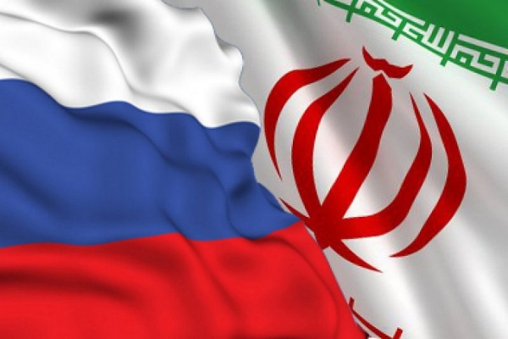

**Speaker:** Vladimir Kulakov, Candidate of Historical Sciences, Associate Professor, Head of the Chair for International History and Regional Studies, Astrakhan State University.

Take a tour of the history of the ongoing development of Russian-Iranian relations through the prism of the perennial interregional cooperation experience. Astrakhan region boasts an extensive expertise, when it comes to the mutually beneficial collaboration with Iran's northern provinces. Historic background and its tremendous impact on the present-day Russian-Iranian strategic cooperation will be thoroughly discussed during the lecture.

**Duration** approximately 45 minutes.

**Preliminary date**: late May, 15:00 Moscow time (*pending confirmation*)

**Stay tuned and watch for updates!**